Assignments :-

Assignment 1)
Creation of Virtual Directory, Home directory, Home page, hosting of website

Assignment 2)
Demonstrate Page Life Cycle of ASP.NET. Use important page events for your demonstration.

using System;
using System.Configuration;
using System.Data;
using System.Linq;
using System.Web;
using System.Web.Security;
using System.Web.UI;
using System.Web.UI.HtmlControls;
using System.Web.UI.WebControls;
using System.Web.UI.WebControls.WebParts;
using System.Xml.Linq;
public partial class _Default : System.Web.UI.Page
{
protected void Page_PreInit(object sender, EventArgs e)
{
//Work and It will assign the values to label.
Label1.Text = Label1.Text + "<br/>" + "PreInit";
} protected void Page_Init(object sender, EventArgs e)
{
//Work and It will assign the values to label.
Label1.Text = Label1.Text + "<br/>" + "Init";
} protected void Page_InitComplete(object sender, EventArgs e)
{
//Work and It will assign the values to label.
Label1.Text = Label1.Text + "<br/>" + "InitComplete";
} protected override void OnPreLoad(EventArgs e)
{
//Work and It will assign the values to label.
//If the page is post back, then label contrl values will be loaded
from view state.
//E.g: If you string str = Label1.Text, then str will contain
viewstate values.
Label1.Text = Label1.Text + "<br/>" + "PreLoad";
} protected void Page_Load(object sender, EventArgs e)
{
//Work and It will assign the values to label.
Label1.Text = Label1.Text + "<br/>" + "Load";
} protected void Button1_Click(object sender, EventArgs e)
{
//Work and It will assign the values to label.
Label1.Text = Label1.Text + "<br/>" + "btnSubmit_Click";
} protected void Page_LoadComplete(object sender, EventArgs e)
{
//Work and It will assign the values to label.
Label1.Text = Label1.Text + "<br/>" + "LoadComplete";
} protected override void OnPreRender(EventArgs e)
{
//Work and It will assign the values to label.
Label1.Text = Label1.Text + "<br/>" + "PreRender";
} protected override void OnSaveStateComplete(EventArgs e)
{
//Work and It will assign the values to label.
//But "SaveStateComplete" values will not be available during post
back. i.e. View state.
Label1.Text = Label1.Text + "<br/>" + "SaveStateComplete";
} protected void Page_UnLoad(object sender, EventArgs e)
{
//Work and it will not effect label contrl, view stae and post back
data.
Label1.Text = Label1.Text + "<br/>" + "UnLoad";
}
}

OUTPUT:-
Before Button Click After Button Click

Assignment 3)
Write VB.Net/C# console applications to demonstrate: OO concepts:
polymorphism, encapsulation, inheritance, interface inheritance, abstract classes/methods, overloading, overriding, collection classes, properties

using System;
using System.Collections;
//Function Overloading
/*class Program
{
public void add(int a, int b)
{
Console.WriteLine(a + b);
} public void add(float x, float y)
{
Console.WriteLine(x + y);
} public void add(string s1, string s2)
{
Console.WriteLine(s1 + s2);
} static void Main(string[] args)
{
Program obj = new Program();
obj.add(10, 20);
obj.add(10.5f, 20.5f);
obj.add("pranaya", "kumar");
Console.WriteLine("Press any key to exist.");
Console.ReadKey();
}
}*/
//Function Overriding
/*class Class1
{
public virtual void show()
{
Console.WriteLine("Super class show method");
}
}
class Class2 : Class1
{
public override void show()
{
Console.WriteLine("Sub class override show method");
}
} class Program
{
static void Main(string[] args)
{
Class2 obj = new Class2();
obj.show();
Console.ReadKey();
}
}*/
//Function Hiding
/*class Class1
{
public void display()
{
Console.WriteLine("Super class display method");
}
} class Class2 :
Class1
{
public new void display()
{
Console.WriteLine("Sub class display method");
}
} class Program
{
static void Main(string[] args)
{
Class2 obj = new Class2();
obj.display();
Console.ReadKey();
}
}*/
//Encapsulation
/*public class Bank
{
//hiding class data by declaring the variable as private
private double balance;
//creating public setter and getter methods
public double getBalance()
{
//add validation logic if needed
return balance;
} public void setBalance(double balance)
{
// add validation logic to check whether data is correct or not
this.balance = balance;
}
} class BankUser
{
public static void Main()
{
Bank SBI = new Bank();
SBI.setBalance(500);
Console.WriteLine(SBI.getBalance());
Console.WriteLine("Press any key to exist.");
Console.ReadKey();
}
}*/
//inheritance
/*class Branch
{
int BranchCode;
string BranchName, BranchAddress;
public void GetBranchData()
{
Console.WriteLine("ENTER BRANCH DETAILS:");
Console.WriteLine("ENTER BRANCH CODE");
BranchCode = int.Parse(Console.ReadLine());
Console.WriteLine("ENTER BRANCH NAME");
BranchName = Console.ReadLine();
Console.WriteLine("ENTER BRANCH ADDRESS");
BranchAddress = Console.ReadLine();
} public void DisplayBranchData()
{
Console.WriteLine("BRANCH CODE IS : " + BranchCode);
Console.WriteLine("BRANCH NAME IS : " + BranchName);
Console.WriteLine("BRANCH ADDRESS IS : " + BranchAddress);
}
} class Employee :
Branch
{
int EmployeeId, EmployeeAge;
string EmployeeName, EmployeeAddress;
public void GetEmployeeData()
{
Console.WriteLine("ENTER EMPLYEE DETAILS:");
Console.WriteLine("ENTER EMPLOYEE ID");
EmployeeId = int.Parse(Console.ReadLine());
Console.WriteLine("ENTER EMPLOYEE AGE");
EmployeeAge = int.Parse(Console.ReadLine());
Console.WriteLine("ENTER EMPLOYEE NAME");
EmployeeName = Console.ReadLine();
Console.WriteLine("ENTER EMPLOYEE ADDRESS");
EmployeeAddress = Console.ReadLine();
} public void DisplayEmployeeData()
{
Console.WriteLine("EMPLOYEE ID IS : " + EmployeeId);
Console.WriteLine("EMPLOYEE NAME IS : " + EmployeeName);
Console.WriteLine("EMPLOYEE ADDRESS IS : " + EmployeeAddress);
Console.WriteLine("EMPLOYEE AGE IS : " + EmployeeAge);
}
} class Program
{
static void Main(string[] args)
{
Employee obj1 = new Employee();
obj1.GetBranchData();
obj1.GetEmployeeData();
obj1.DisplayBranchData();
obj1.DisplayEmployeeData();
Console.WriteLine("Press any key to exist.");
Console.ReadKey();
}
}*/
//interface inheritance
/*public interface A
{
void method1();
void method2();
} interface B
:
A
{
void method3();
} class MyClass :
B
{
public void method1()
{
Console.WriteLine("implement method1");
} public void method2()
{
Console.WriteLine("implement method2");
} public void method3()
{
Console.WriteLine("implement method3");
}
} class Program
{
static void Main(string[] args)
{
MyClass obj = new MyClass();
obj.method1();
obj.method2();
obj.method3();
Console.WriteLine("Press any key to exist.");
Console.ReadKey();
}
}*/
//Abstract classes/methods
/*public abstract class MyClass
{
public abstract void calculate(double x);
public void show()
{
Console.WriteLine("Show");
}
} class Sub1 : MyClass
{
public override void calculate(double x)
{
Console.WriteLine("SQUARE ROOT IS " + Math.Sqrt(x));
}
} class Test
{
static void Main(string[] args)
{
Sub1 obj1 = new Sub1();
obj1.calculate(9);
obj1.show();
Console.ReadKey();
}
}*/
//Collection Classes Stack, Queue, LinkedList, SortedList, ArrayList,
HashTable, etc.
/*class Program
{
static void Main(string[] args)
{
//Createing ArrayList collection using default constructor
ArrayList al = new ArrayList();
Console.WriteLine("Initial Capacity: " + al.Capacity);
al.Add(10);
Console.WriteLine("Capacity after adding first item: " +
al.Capacity);
al.Add("hello");
al.Add(true);
al.Add(3.14f);
Console.WriteLine("Capacity after adding fourth item: " +
al.Capacity);
al.Add('A');
Console.WriteLine("Capacity after adding 5th element: " +
al.Capacity);
//Printing the ArrayList elements using for loop
for (int i = 0; i < al.Count; i++)
{
Console.Write(al[i] + " ");
} Console.WriteLine();
//Removing the values from the middle of the array list
//here we are removing by value
al.Remove(true);
//You can also remove element by using index position
// al.RemoveAt(2);
//Printing the ArrayList elements using foreach loop after
// removing an element from the collection
foreach (object obj in al)
{
Console.Write(obj + " ");
} Console.WriteLine();
//inserting values into the middle of the array list collection
al.Insert(2, false);
// Printing the values of the collection using foreach loop after
// inserting an element into the middle of the collection
foreach (object obj in al)
{
Console.Write(obj + " ");
} Console.WriteLine();
// creating new ArrayList collection by passing the old
// array list as parameter
ArrayList coll = new ArrayList(al);
Console.WriteLine("Initial capacity of new array list collection:" +
coll.Capacity);
// Printing the values of the new array list collection using
foreach loop
foreach (object obj in coll)
{
Console.Write(obj + " ");
} Console.ReadKey();
}
}*/
//Properties
public class Example
{
private int _empid, _eage;
private string _ename, _eaddress;
public int empid
{
set
{
_empid = value;
} get
{
return _empid;
}
} public int eage
{
set
{
_eage = value;
} get
{
return _eage;
}
} public string ename
{
set
{
_ename = value;
} get
{
return _ename;
}
} public string eaddress
{
set
{
_eaddress = value;
} get
{
return _eaddress;
}
}
} class Program
{
static void Main(string[] args)
{
Example obj1 = new Example();
obj1.empid = 101;
obj1.ename = "abc";
obj1.eage = 27;
obj1.eaddress = "shirpur";
Console.WriteLine("Employee details are:");
Console.WriteLine("employee id:" + obj1.empid);
Console.WriteLine("employee name:" + obj1.ename);
Console.WriteLine("employee age:" + obj1.eage);
Console.WriteLine("employee address:" + obj1.eaddress);
Console.ReadKey();
}
}

OUTPUT:-

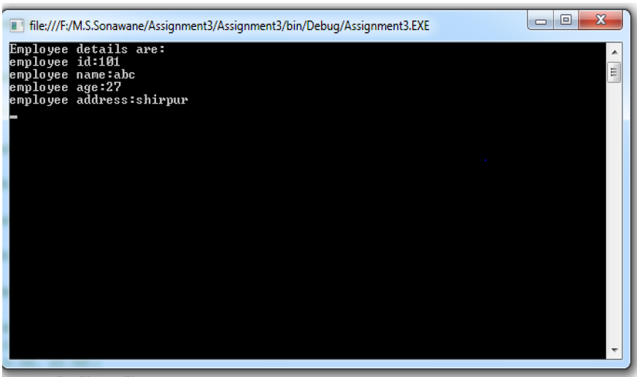

Assignment 4)
Demonstrate concept of postback and viewstate using web form server
controls of ASP.NET
using System;
using System.Collections.Generic;
using System.Linq;
using System.Web;
using System.Web.UI;
using System.Web.UI.WebControls;

namespace Practical_No_4
{
public partial class WebForm1 : System.Web.UI.Page
{
protected void Page_Load(object sender, EventArgs e)
{
bind1();
bind2();
}

public void bind1()
{
ListItem l1 = new ListItem("california");
ListItem l2 = new ListItem("LA");
ListItem l3 = new ListItem("New York");
DropDownList1.Items.Add(l1);
DropDownList1.Items.Add(l2);
DropDownList1.Items.Add(l3);
}
protected void bind2()
{
ListItem l1 = new ListItem("california");
ListItem l2 = new ListItem("LA");
ListItem l3 = new ListItem("New York");
DropDownList2.Items.Add(l1);
DropDownList2.Items.Add(l2);
DropDownList2.Items.Add(l3);
}

protected void Button1_Click(object sender, EventArgs e)
{

}
}
}
OUTPUT:-

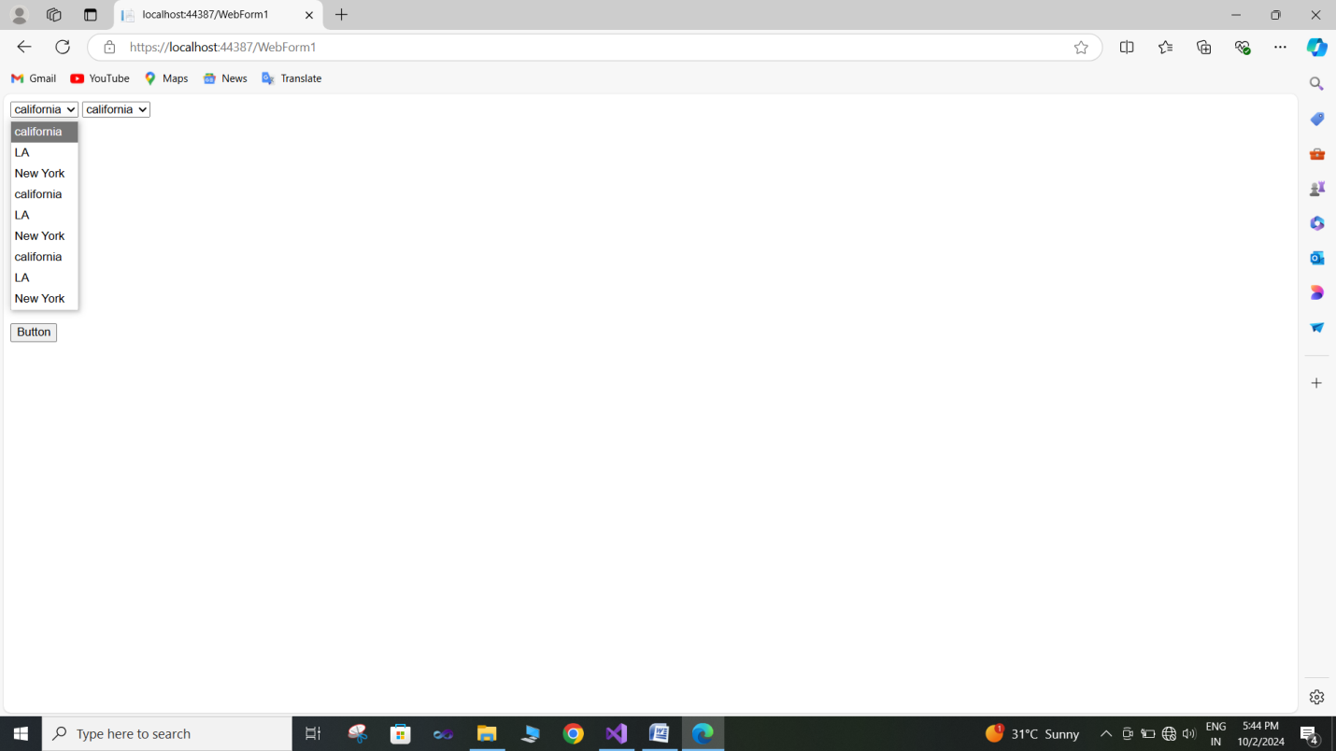

Assignment 5)
Demonstrate various Web form server controls using sample data entry
screen form for registering for a service on website. Also use validation controls to validate input data.

.aspx.cs code:

using System;
using System.Collections.Generic;
using System.Linq;
using System.Web;
using System.Web.UI;
using System.Web.UI.WebControls;

namespace Practical_No_5
{
public partial class WebForm1 : System.Web.UI.Page
{
protected void Page_Load(object sender, EventArgs e)
{

}
protected void btnSubmit_Click(object sender, EventArgs e)
{
if (Page.IsValid)
{
// Here, you would typically save the data to a database or perform other actions
lblMessage.Text = "Registration successful!";
}
}
}
}

.aspx code :
<%@ Page Language="C#" AutoEventWireup="true" CodeBehind="WebForm1.aspx.cs" Inherits="Practical_No_5.WebForm1" %>

<!DOCTYPE html>

<html xmlns="http://www.w3.org/1999/xhtml">
<head runat="server">
<title></title>
</head>
<body>
<form id="form1" runat="server">
<div>
<h2>Register for Our Service</h2>
<asp:Label ID="lblUsername" runat="server" Text="Username:" AssociatedControlID="txtUsername"></asp:Label>
<asp:TextBox ID="txtUsername" runat="server"></asp:TextBox>
<asp:RequiredFieldValidator ID="rfvUsername" runat="server" ControlToValidate="txtUsername"
ErrorMessage="Username is required." ForeColor="Red"></asp:RequiredFieldValidator>
<br />

<asp:Label ID="lblEmail" runat="server" Text="Email:" AssociatedControlID="txtEmail"></asp:Label>
<asp:TextBox ID="txtEmail" runat="server"></asp:TextBox>
<asp:RequiredFieldValidator ID="rfvEmail" runat="server" ControlToValidate="txtEmail"
ErrorMessage="Email is required." ForeColor="Red"></asp:RequiredFieldValidator>
<asp:RegularExpressionValidator ID="revEmail" runat="server" ControlToValidate="txtEmail"
ErrorMessage="Invalid email format." ForeColor="Red"
ValidationExpression="^[^@\s]+@[^@\s]+\.[^@\s]+$"></asp:RegularExpressionValidator>
<br />

<asp:Label ID="lblPassword" runat="server" Text="Password:" AssociatedControlID="txtPassword"></asp:Label>
<asp:TextBox ID="txtPassword" runat="server" TextMode="Password"></asp:TextBox>
<asp:RequiredFieldValidator ID="rfvPassword" runat="server" ControlToValidate="txtPassword"
ErrorMessage="Password is required." ForeColor="Red"></asp:RequiredFieldValidator>
<asp:RegularExpressionValidator ID="revPassword" runat="server" ControlToValidate="txtPassword"
ErrorMessage="Password must be at least 6 characters long." ForeColor="Red"
ValidationExpression="^.{6,}$"></asp:RegularExpressionValidator>
<br />

<asp:Label ID="lblConfirmPassword" runat="server" Text="Confirm Password:" AssociatedControlID="txtConfirmPassword"></asp:Label>
<asp:TextBox ID="txtConfirmPassword" runat="server" TextMode="Password"></asp:TextBox>
<asp:RequiredFieldValidator ID="rfvConfirmPassword" runat="server" ControlToValidate="txtConfirmPassword"
ErrorMessage="Confirm Password is required." ForeColor="Red"></asp:RequiredFieldValidator>
<asp:CompareValidator ID="cvPassword" runat="server" ControlToCompare="txtPassword"
ControlToValidate="txtConfirmPassword" ErrorMessage="Passwords do not match." ForeColor="Red"></asp:CompareValidator>
<br />

<asp:Button ID="btnSubmit" runat="server" Text="Register" OnClick="btnSubmit_Click" />
<asp:Label ID="lblMessage" runat="server" ForeColor="Green"></asp:Label>

</div>
</form>
</body>
</html>

OUTPUT:-

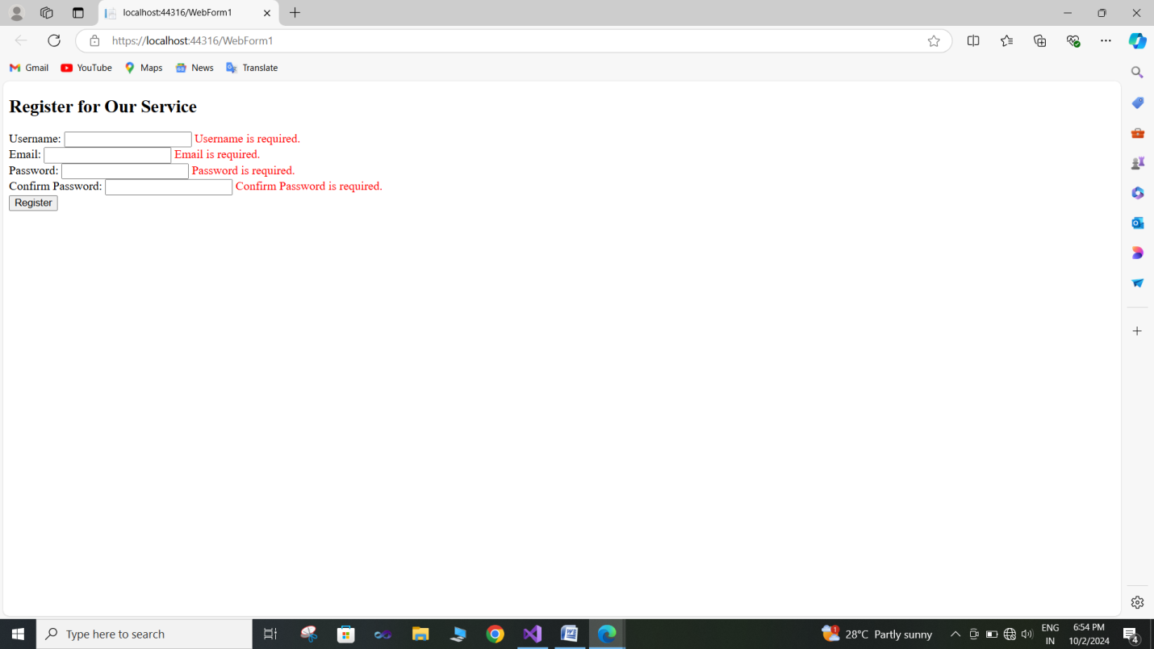

Assignment 6)
Demonstrate DropDownList box, CheckButtonList, RadioButtonList controls.
.aspx.cs code :
using System;
using System.Collections.Generic;
using System.Linq;
using System.Web;
using System.Web.UI;
using System.Web.UI.WebControls;

namespace Practical_No_6
{
public partial class WebForm1 : System.Web.UI.Page
{
protected void Page_Load(object sender, EventArgs e)
{

}
protected void btnSubmit_Click(object sender, EventArgs e)
{
string selectedCountry = ddlCountry.SelectedItem.Text;
string selectedHobbies = string.Join(", ", cblHobbies.Items.Cast<ListItem>().Where(i => i.Selected).Select(i => i.Text));
string selectedSubscription = rblSubscription.SelectedItem != null ? rblSubscription.SelectedItem.Text : "None";

lblMessage.Text = $"You selected: Country - {selectedCountry}, Hobbies - {selectedHobbies}, Subscription - {selectedSubscription}";
}
}
}
.aspx code :
<%@ Page Language="C#" AutoEventWireup="true" CodeBehind="WebForm1.aspx.cs" Inherits="Practical_No_6.WebForm1" %>

<!DOCTYPE html>

<html xmlns="http://www.w3.org/1999/xhtml">
<head runat="server">
<title></title>
</head>
<body>
<form id="form1" runat="server">
<div>
<h2>Select Your Preferences</h2>

<asp:Label ID="lblCountry" runat="server" Text="Select Your Country:" AssociatedControlID="ddlCountry"></asp:Label>
<asp:DropDownList ID="ddlCountry" runat="server">
<asp:ListItem Value="US">United States</asp:ListItem>
<asp:ListItem Value="CA">Canada</asp:ListItem>
<asp:ListItem Value="UK">United Kingdom</asp:ListItem>
<asp:ListItem Value="AU">Australia</asp:ListItem>
</asp:DropDownList>
<br /><br />

<asp:Label ID="lblHobbies" runat="server" Text="Select Your Hobbies:" AssociatedControlID="cblHobbies"></asp:Label>
<asp:CheckBoxList ID="cblHobbies" runat="server">
<asp:ListItem Value="Reading">Reading</asp:ListItem>
<asp:ListItem Value="Traveling">Traveling</asp:ListItem>
<asp:ListItem Value="Cooking">Cooking</asp:ListItem>
<asp:ListItem Value="Gaming">Gaming</asp:ListItem>
</asp:CheckBoxList>
<br /><br />

<asp:Label ID="lblSubscription" runat="server" Text="Select Subscription Type:" AssociatedControlID="rblSubscription"></asp:Label>
<asp:RadioButtonList ID="rblSubscription" runat="server">
<asp:ListItem Value="Free">Free</asp:ListItem>
<asp:ListItem Value="Premium">Premium</asp:ListItem>
<asp:ListItem Value="Pro">Pro</asp:ListItem>
</asp:RadioButtonList>
<br /><br />

<asp:Button ID="btnSubmit" runat="server" Text="Submit Preferences" OnClick="btnSubmit_Click" />
<asp:Label ID="lblMessage" runat="server" ForeColor="Green"></asp:Label>

</div>
</form>
</body>
</html>

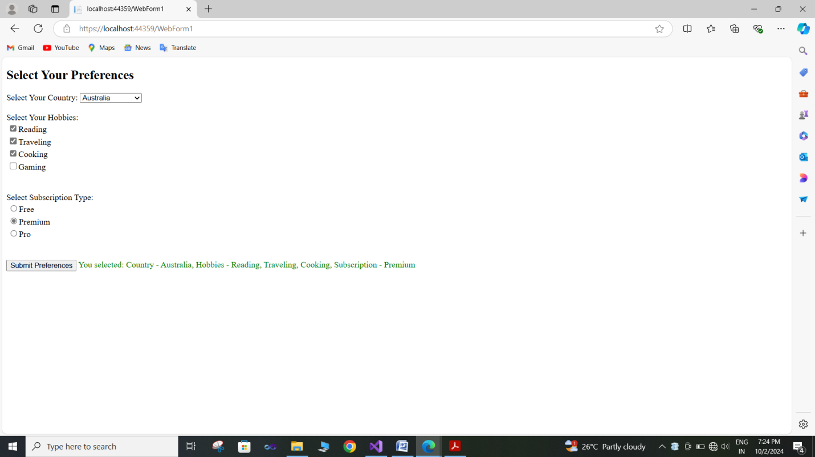

Assignment 7) Demonstrate Databinding using Hashtable, ArraryList, DataTable data
sources.
using System;
using System.Collections;
using System.Data;
using System.Collections.Generic;
using System.Linq;
using System.Web;
using System.Web.UI;
using System.Web.UI.WebControls;

namespace Practical_No_7
{
public partial class WebForm1 : System.Web.UI.Page
{
protected void Page_Load(object sender, EventArgs e)
{
if (!IsPostBack)
{
// Create and bind Hashtable
Hashtable hashtable = new Hashtable
{
{ "One", 1 },
{ "Two", 2 },
{ "Three", 3 }
};

foreach (DictionaryEntry entry in hashtable)
{
ListBox1.Items.Add($"{entry.Key}: {entry.Value}");
}
}
if (!IsPostBack)
{
// Create and bind ArrayList
ArrayList arrayList = new ArrayList
{
"Apple",
"Banana",
"Cherry"
};

ListBox2.DataSource = arrayList;
ListBox2.DataBind();
}
if (!IsPostBack)
{
// Create and bind DataTable
DataTable dataTable = new DataTable();
dataTable.Columns.Add("Name", typeof(string));
dataTable.Columns.Add("Age", typeof(int));

dataTable.Rows.Add("Alice", 30);
dataTable.Rows.Add("Harry", 25);
dataTable.Rows.Add("Charlie", 35);

GridView1.DataSource = dataTable;
GridView1.DataBind();
}
}
}
}

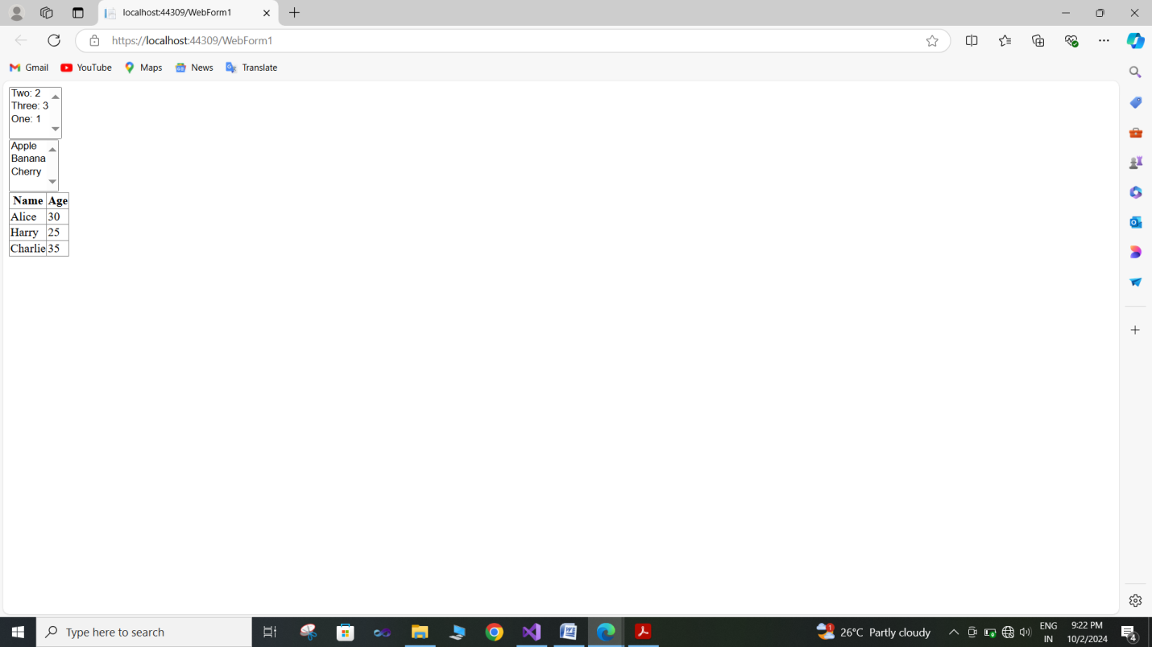

Assignment 8) Demonstrate Repeater control with the help of various templates.
.aspx.cs code:-
using System;
using System.Collections.Generic;
using System.Diagnostics;
using System.Data;
using System.Web.UI;
using System.Linq;
using System.Web;
using System.Web.UI.WebControls;

namespace Practical_Num_8
{
public partial class WebForm1 : System.Web.UI.Page
{
protected void Page_Load(object sender, EventArgs e)
{
if (!IsPostBack)
{
BindRepeater();
}

}
private void BindRepeater()
{
List<Item> items = new List<Item>
{
new Item { ID = 1, Name = "Item 1", Description = "Description 1" },
new Item { ID = 2, Name = "Item 2", Description = "Description 2" },
new Item { ID = 3, Name = "Item 3", Description = "Description 3" },
new Item { ID = 4, Name = "Item 4", Description = "Description 4" }
};

Repeater1.DataSource = items;
Repeater1.DataBind();
}

public class Item
{
public int ID { get; set; }
public string Name { get; set; }
public string Description { get; set; }
}
}
}
.aspx code :-
<%@ Page Language="C#" AutoEventWireup="true" CodeBehind="WebForm1.aspx.cs" Inherits="Practical_Num_8.WebForm1" %>

<!DOCTYPE html>

<html xmlns="http://www.w3.org/1999/xhtml">
<head runat="server">
<title>Repeater Control Demo</title>
</head>
<body>
<form id="form1" runat="server">
<div>
<asp:Repeater ID="Repeater1" runat="server">
<HeaderTemplate>
<h2>Items List</h2>
<table border="1" style="width:100%;">
<tr>
<th>ID</th>
<th>Name</th>
<th>Description</th>
</tr>
</HeaderTemplate>
<ItemTemplate>
<tr>
<td><%# Eval("ID") %></td>
<td><%# Eval("Name") %></td>
<td><%# Eval("Description") %></td>
</tr>
</ItemTemplate>
<AlternatingItemTemplate>
<tr style="background-color:#f9f9f9;">
<td><%# Eval("ID") %></td>
<td><%# Eval("Name") %></td>
<td><%# Eval("Description") %></td>
</tr>
</AlternatingItemTemplate>
<FooterTemplate>
</table>
</FooterTemplate>
</asp:Repeater>
</div>
</form>
</body>
</html>

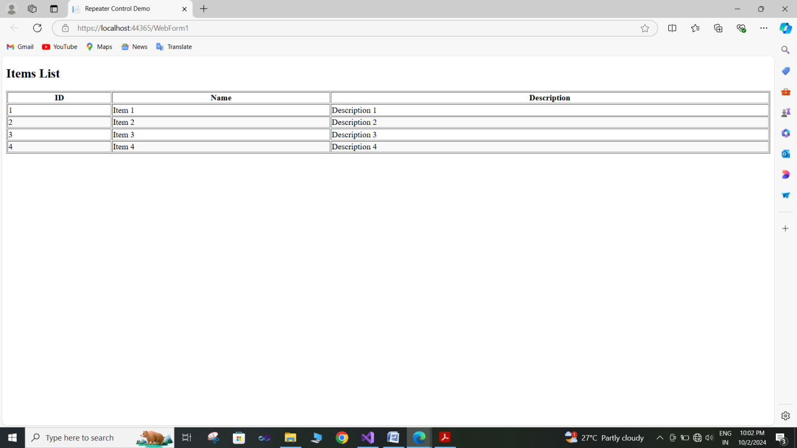

Assignment 9) Demonstrate paging, sorting, filtering of data in
asp:DataGrid/DataGridView.
Assignment 11) Demonstrate State Management features of ASP.NET using sample shopping cart application

1.Start->Programs->Visual studio 2008
2.Create new web site.
3. Take Label1, Button1
4. Write following code

protected void Button1_Click(object sender, EventArgs e)
{
Session["Count"] = Convert.ToInt32(Session["Count"]) + 1;//Set Value to
The Session
Label1.Text = Session["Count"].ToString(); //Get Value from the Sesion
}

5. Take Label2, Button2, HiddentField1, Set HiddentField1.Value=0
6. Write following code

protected void Button2_Click(object sender, EventArgs e)
{
if (HiddenField1.Value != null)
{
try
{
int val = Convert.ToInt32(HiddenField1.Value) + 1;
HiddenField1.Value = val.ToString();
Label2.Text = val.ToString();
} catch (
Exception exc)
{
Response.Write(exc);
}
}
}

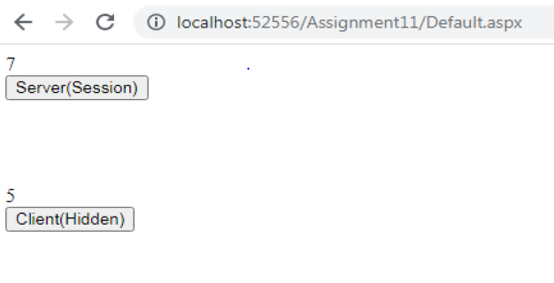

Assignment 12) Create sample website for demonstrating use of Profiles/Themes using skin files.

Assignment 13) Demonstrate Master Pages and website navigation controls (sitemap path, treeview, menu) using SiteMap file.

